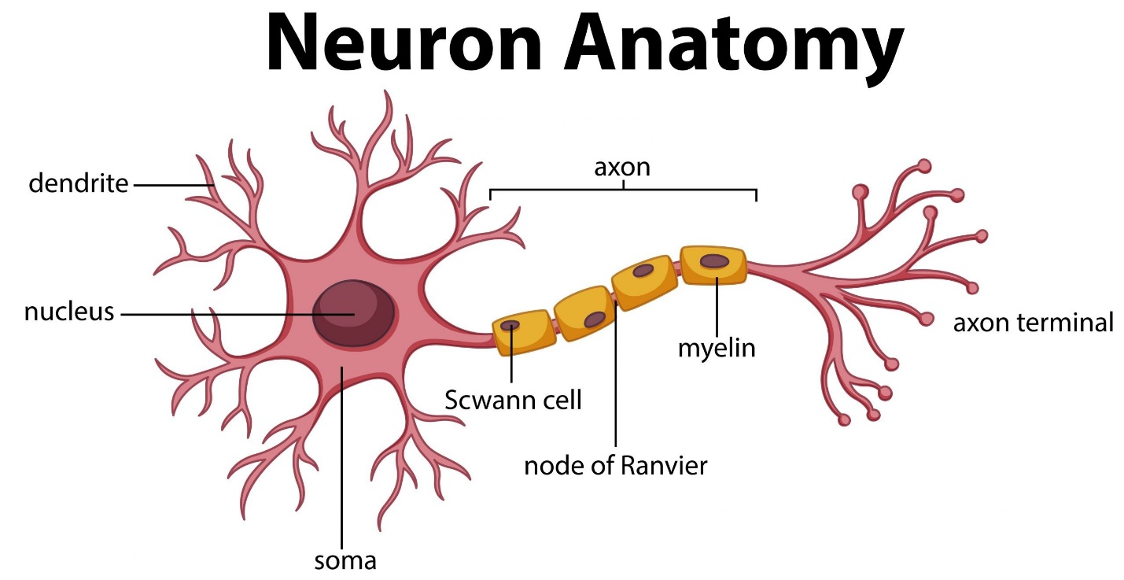

Neural network – foundation

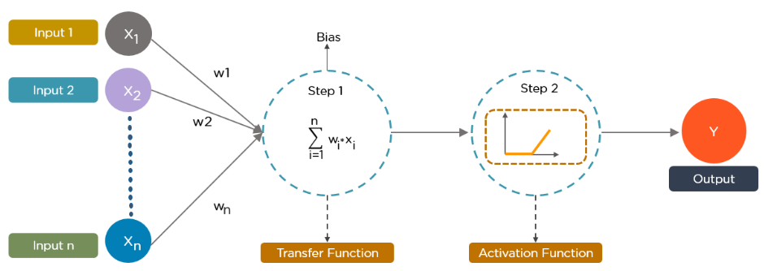

*Image Source: superdatascience.com*

1. Singals form multiple neurons, like (x1,x2,……xn) along with weights w1,w2,..wn – transmitted the scusseive neurons. (input layers)
2. Associated weights with in multiple neurons.
3. Activation function
4. Neuron understand if it need to pass the signals
5. The singles – another neuron/ our output layers.
6. Repeating the process until the last neuron

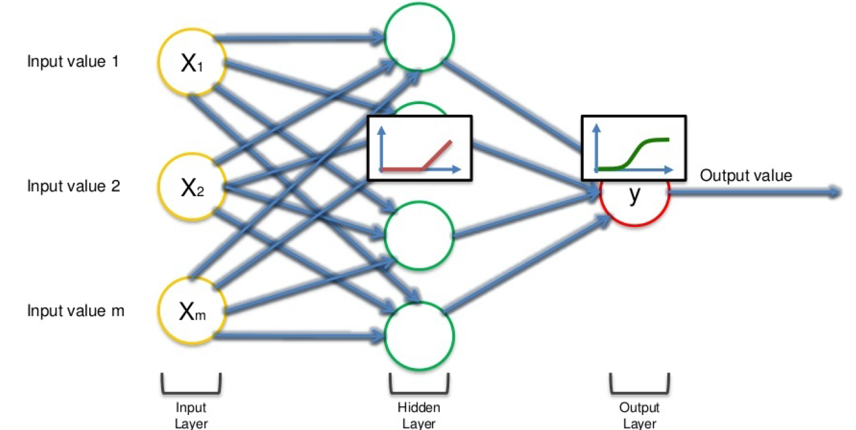

*Image Source: superdatascience.com*

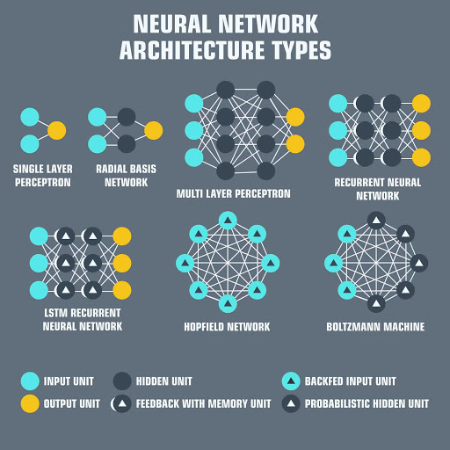

Image Source: aalerin.com



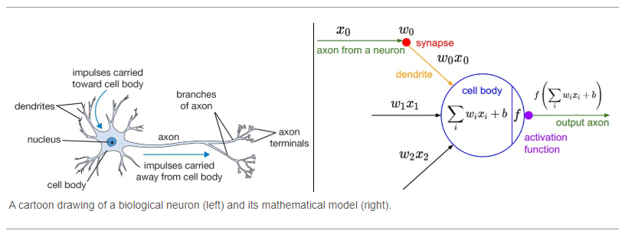

Activation Function :

1. Linear Function

Linear data

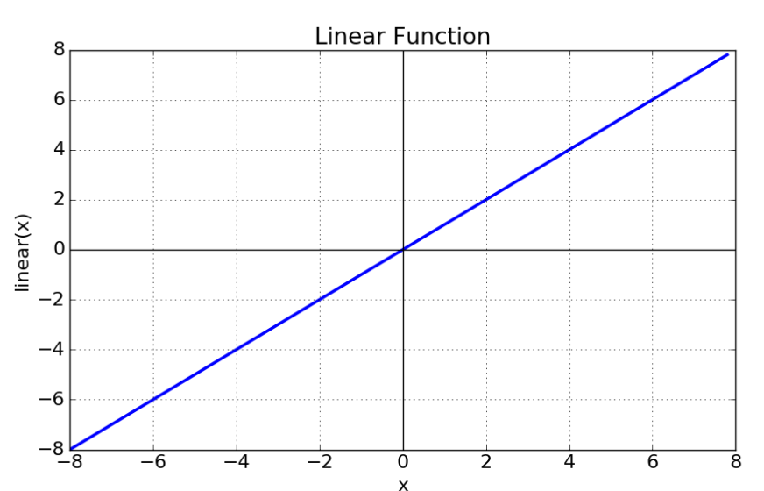

Non Linear Data

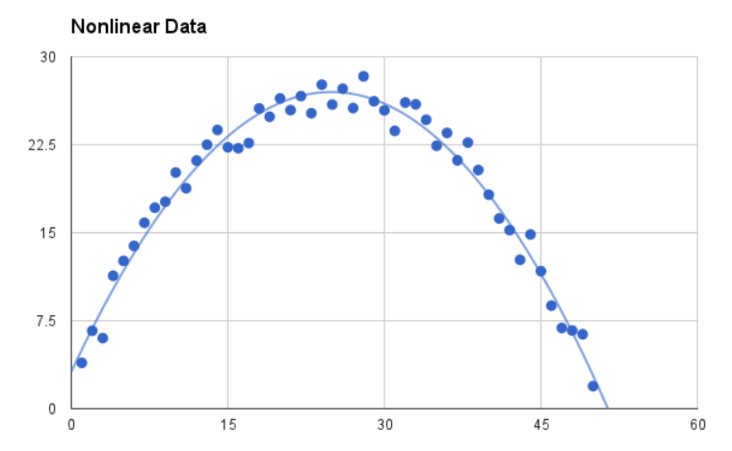

1. Differential function

Y axis x-- slope

1. Monotonic function
2. Vanishing Gradient problem
3. Zero Centred
4. Computational inexpensive
5. Differentiable

Sigmoid function: (0-1) :

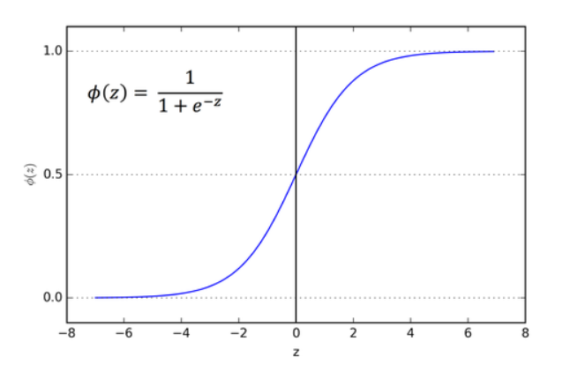

1. Hyperbolic Tangent function (Tanh)

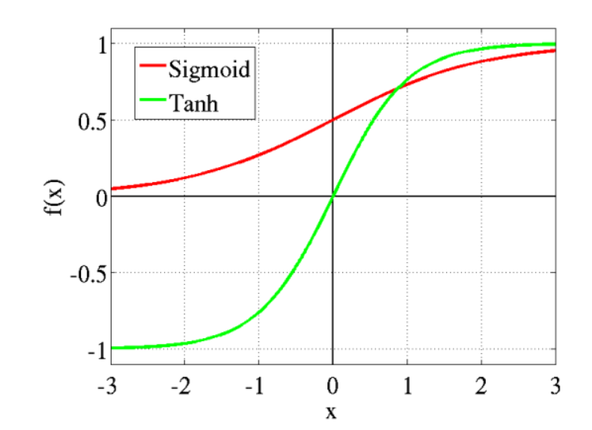

1. Softmax function

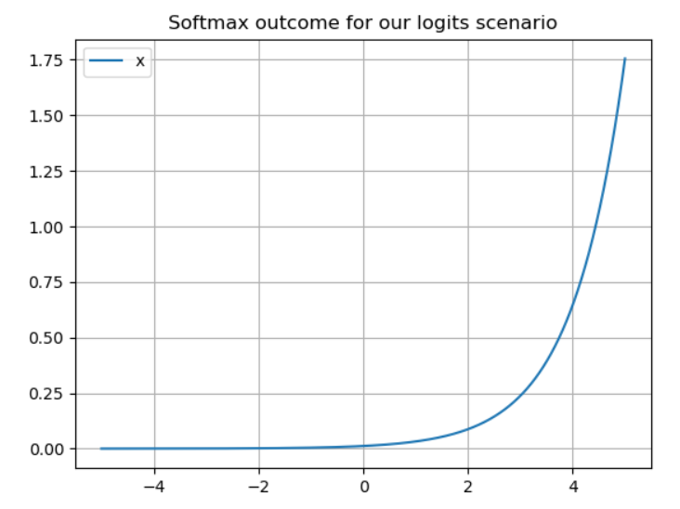

4. Rectified Linear unit (ReLU)

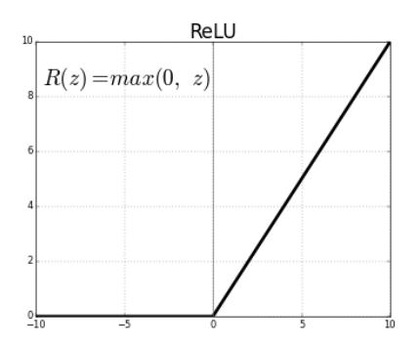

1. Leaky ReLU

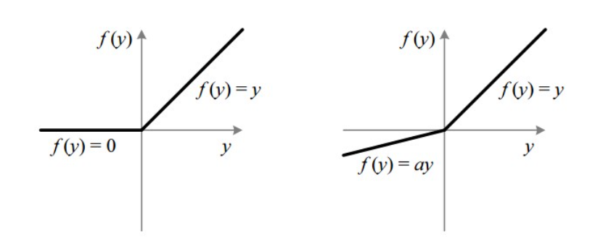

6.Exponential Linear Units (ELU)

